**Front-End UI/UX Mini Project**

**1. Title Page**

* **Project Title:** Holiday Planner
* **Submitted By:**
  + **Team Members:** Neha Tresa Boby

Tania Robby

* + **Roll Number(s):** 2460411

2461032

* + **College Email ID:** [neha.tresa@btech.christuniversity.in](mailto:neha.tresa@btech.christuniversity.in)

[tania.robby@btech.christuniversity.in](mailto:tania.robby@btech.christuniversity.in)

* **Course:** *UI/UX Design Fundamentals*
* **Instructor Name:** Mr. Narendra Kumar
* **Institution:** *Christ (Deemed to be University)*
* **Date of Submission:** 26/09/2025

**2. Abstract**

This project focuses on designing and developing a responsive and user-friendly holiday planner website aimed at simplifying the entire process of organizing vacations. The site’s primary goal is to allow users to search for destinations, select accommodation and transport, plan activities, and create a comprehensive travel itinerary while tracking their budget. Built using HTML for content structure, CSS for styling, and JavaScript with the jQuerylibrary for dynamic interactivity, the website leverages the Bootstrap framework to ensure responsive design across all devices. It showcases a wide range of destinations, booking options, activity planners, and budget trackers intuitively and engagingly. The final product is an all-in-one, user-friendly platform that effectively consolidates all aspects of trip planning, making it easy for visitors to build, view, and manage their perfect vacation. This enhances the user's travel planning experience and facilitates a more organized, enjoyable, and budget-conscious holiday.

.

**3. Objectives**

* **Implement a Dynamic Destination Search**

Develop an intuitive search feature that allows users to find vacation spots based on specific interests such as beaches, mountains, or cities, providing a user-friendly way to discover travel options.

* **Develop an Interactive Planning Module**

Create a seamless interface for users to browse, select, and add accommodation, flights, and other transportation options to their plan, using JavaScript and jQuery to handle user interactions dynamically.

* **Build a Detailed Itinerary Creator and Activity Planner**

Enable users to select destination-specific activities (e.g., sightseeing, adventure sports) and automatically organize them into a detailed trip itinerary with specific dates and times for a clear, chronological schedule.

* **Integrate an Automated Budget Tracker**

Implement a feature to automatically estimate and track the costs of selected flights, accommodation, and activities, providing users with a real-time overview of their total vacation expenses.

* **Ensure a Fully Responsive and Mobile-Friendly Layout**

Utilize the Bootstrap framework to build a responsive website that ensures an optimal and consistent user experience across a wide range of devices, from mobile phones to desktops.

**4. Scope of the Project**

The scope of this project is to design and develop a fully functional front-end holiday planner application, focusing on the client-side user experience and interactivity. It does not involve any backend programming, server-side logic, or database integration. All features, from planning and searching to budget tracking, are implemented using HTML5, CSS3, JavaScript, and the jQuery library, with the Bootstrap framework utilized for responsive design.

The application is designed to be fully responsive, ensuring a seamless and intuitive user interface across desktop, tablet, and mobile viewports. The scope includes the implementation of key interactive modules: a dynamic destination search, an interactive itinerary creator, and a client-side budget tracker that updates in real-time. All data is managed on the client side to simulate a complete application workflow.

This project’s scope is centred on creating a robust and engaging proof-of-concept that effectively demonstrates a modern travel planning tool. It serves as a strong foundation for future enhancements, such as integration with a backend server for user accounts and connecting to live travel APIs for real-time booking data.

**5. Tools & Technologies Used**

| **Tool/Technology** | **Purpose** |
| --- | --- |
| HTML5 | Defines the website’s markup and organizes content structure using semantic elements for better accessibility and SEO. |
| CSS3 | Handles styling, layout design, responsive behaviour, animations, and visual branding of the website. |
| JS | The core programming language for creating dynamic, interactive websites and modern web applications. |
| jQuery | A classic JavaScript library for simplified DOM interaction, still common in legacy projects and WordPress. |
| Bootstrap | A popular CSS framework for building responsive, mobile-first websites with pre-built components and utilities. |
| VS Code | Used as the primary code editor for writing, editing, and managing HTML and CSS files. |
| Chrome DevTools | Utilized for real-time testing, debugging, and optimizing the website’s layout and responsiveness across different devices. |

**6. HTML Structure Overview**

The website is built using semantic HTML5 tags to ensure clarity, accessibility, and search engine optimization. Core semantic elements used include:

* **<header>:** Contains the main heading, navigation bar, and user action icons, serving as the consistent entry point on the main page.
* **<nav>:** Houses the primary navigation links, allowing users to move between different sections and pages of the website.
* **<section>:** Each major content area (e.g., "Home," "Explore," "Services," "Gallery," "Review," "Contact") is encapsulated in a <section> tag, creating a clear and logical document outline.
* **<form>:** Used for all interactive user input, including the login form, search bar, contact form, and the itinerary/budget planners.
* **<footer>:** Located in the index5.html file, it contains concluding information such as quick links, contact details, social media connections, and credits, providing a consistent end-of-page experience.
* **<h1>, <h3>, <h4>:** Headings are used hierarchically to structure content within each section, improving readability and defining the importance of information.

The structure is modular and reusable, allowing sections to be updated or rearranged easily. The navigation menu, implemented with <ul> and <a> tags, enables smooth, in-page scrolling between sections and navigation to the different HTML pages.

.

**7. CSS / Bootstrap Styling Strategy**

* **CSS Custom Properties (Variables):** A central :root block in each stylesheet defines a consistent color palette (e.g., --orange, --black) and spacing, allowing for easy theming and maintenance across all pages.
* **Modern Layout Techniques:** Flexbox is heavily used for aligning items in components like the header, forms, and service boxes. CSS Grid is employed for creating dynamic, responsive galleries and result containers, ensuring content is well-structured on all screen sizes.
* **Responsive Design with Media Queries:** Media queries are implemented to adjust layouts, font sizes, and component visibility for different devices, ensuring the site is fully functional and visually appealing on desktops, tablets, and mobile phones.
* **Transitions and Animations:** Subtle transition effects on interactive elements like buttons and links provide visual feedback. Custom @keyframes animations are used to create engaging effects, such as fade-ins for dynamically loaded content and complex movements in the image carousel.
* **Integration of Third-Party Libraries:** The project seamlessly integrates external libraries like Font Awesome for a rich set of icons and to power the interactive and responsive review slider, enhancing the user interface without relying on a large framework.

This approach ensures visual consistency, maintainability, and a seamless user experience across devices.

**8. JavaScript / jQuery Functionality**

* **DOM Manipulation & Event Handling:** JavaScript is used to dynamically manipulate the HTML and CSS of the page. It controls the visibility of elements like the login form and search bar, handles user interactions through addEventListener, and updates the UI in real-time based on user input.
* **Dynamic Content Rendering:** On the "Explore" page, a local destinations object acts as a mock database. JavaScript dynamically generates and injects HTML for the result cards into the DOM, creating an interactive and filterable discovery tool without page reloads.
* **Interactive UI Components:** The code powers several complex UI components from scratch, including the interactive modals on the "Services" page, the animated image carousel in the "Gallery," and the fully functional itinerary and budget planners.
* **Third-Party Library Integration:** The project effectively integrates other modern libraries. The "Review" section creates a responsive, touch-friendly testimonial slider, demonstrating a modern approach to using specialized tools for specific tasks.
* **State Management:** For features like the itinerary planner, JavaScript manages the application's state in memory using arrays (itineraryItems, budgetItems). Functions are used to add, render, and delete items from these arrays, updating the UI accordingly.

**8. Key Features**

| Feature | Description |
| --- | --- |
| **Responsive Design** | Fully adapts to various screen sizes, ensuring an optimal viewing experience on desktops, tablets, and mobile devices through custom CSS Flexbox, Grid, and media queries. |
| **Interactive Navigation & Forms** | A fixed header contains a responsive navigation bar, a toggleable search bar, and a pop-up login form, all managed with Vanilla JavaScript for a smooth user experience. |
| **Dynamic Destination Filtering** | The "Explore" page features an interactive tool allowing users to search for travel destinations by interest, with results dynamically rendered on the page without a reload. |
| **Interactive Service Modals** | The "Services" section includes clickable cards that launch modal windows for hotels, food, travel, and adventures, providing detailed information in an organized way. |
| **Animated Sliders & Carousels** | The website includes a custom-built, animated image carousel in the "Gallery" and a touch-friendly, responsive review slider powered by the Swiper.js library. |
| **Itinerary & Budget Planner** | A dedicated page where users can dynamically add and delete activities for their trip itinerary and track expenses with a real-time budget calculator. |
| **Contact Form** | A standard contact form is included for users to send messages. The form is visually complete but has no backend integration to process the submissions. |

**9. Challenges Faced & Solutions**

| **Challenge** | **Solution** |
| --- | --- |
| **Managing Multiple Interactive UI States** | To prevent conflicts between the toggling navbar, search bar, and login form, a window.onscroll event was implemented to reset all components to their default state, ensuring a clean and predictable user interface. |
| **Creating a Dynamic Filter without a Backend** | The "Explore" page uses a client-side JavaScript object to store all destination data. A single displayResults function efficiently filters this data and dynamically renders HTML cards, providing instant search results without page reloads. |
| **State Management for the Planner** | For the Itinerary & Budget Planner, client-side state is managed using two simple arrays (itineraryItems, budgetItems). Functions to add or delete items modify these arrays and then trigger a render function to redraw the UI, ensuring the display is always in sync with the data. |
| **Ensuring Responsive Consistency Across Pages** | A consistent visual theme is maintained by defining CSS custom properties (variables) for colors and fonts in the :root of each stylesheet. Each page then implements its own specific media queries, making the responsive design modular and easier to manage. |
| **Implementing Complex Animations Manually** | The animated image carousel in the "Gallery" was built from scratch using Vanilla JavaScript. The logic manipulates the DOM by appending and prepending items within a container on button clicks, creating a seamless and visually engaging looping effect. |

**10. Outcome**

The project successfully culminated in a clean, visually engaging, and highly interactive multi-page front-end application for holiday planning. All core features, from the dynamic destination filtering and interactive modals to the itinerary planner, function exactly as intended. The website was built using a modern technology stack of HTML5, custom CSS3, and JavaScript, frameworks like Bootstrap and jQuery to create a lightweight, custom solution.

Through the development process, a strong understanding of client-side interactivity, layout responsiveness, and state management was demonstrated. The extensive use of modern JavaScript and advanced CSS techniques ensured a feature-rich, adaptable design that works seamlessly across all devices. The final product meets all goals and serves as a robust foundation for future backend integration.

**11. Future Enhancements**

While the current version of the Holiday Planner is a feature-rich front-end application, several improvements can be implemented to transform it into a fully dynamic and professional-grade web service:

* **Backend and Database Integration:** Develop a server-side application (e.g., using Node.js, Python, or PHP) to handle the login, registration, and contact form submissions. This would connect to a database to securely store user data and messages.
* **User Accounts and Data Persistence:** Implement a full user authentication system. This would allow users to register, log in, and save their custom itineraries and budget plans to their personal accounts, making their data accessible across sessions.
* **Dynamic Content via APIs:** Replace the hardcoded JavaScript objects for destinations, hotels, and food with live data fetched from external APIs. This would ensure the content is always up-to-date and allows for a much larger variety of options.
* **Real-Time Booking System:** Integrate with third-party booking APIs (e.g., for flights, hotels, and activities). This would be a major enhancement, allowing users to move from planning to actually booking their entire trip directly through the website.
* **Advanced Filtering and Search:** Enhance the "Explore" page with more sophisticated filtering options, such as searching by date, price range, available activities, or user ratings, to provide a more powerful and personalized discovery experience.

These enhancements would transform the project from a static showcase into an interactive, data-driven platform, increasing its real-world utility and user engagement.

**12. Sample Code and Output**

**>> Dynamic Destination Finder:**

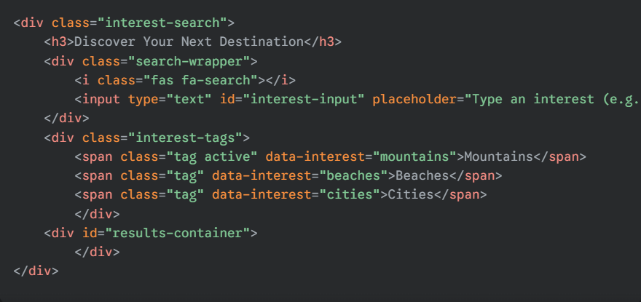



**>> Interactive Itinerary & Budget Planner:**

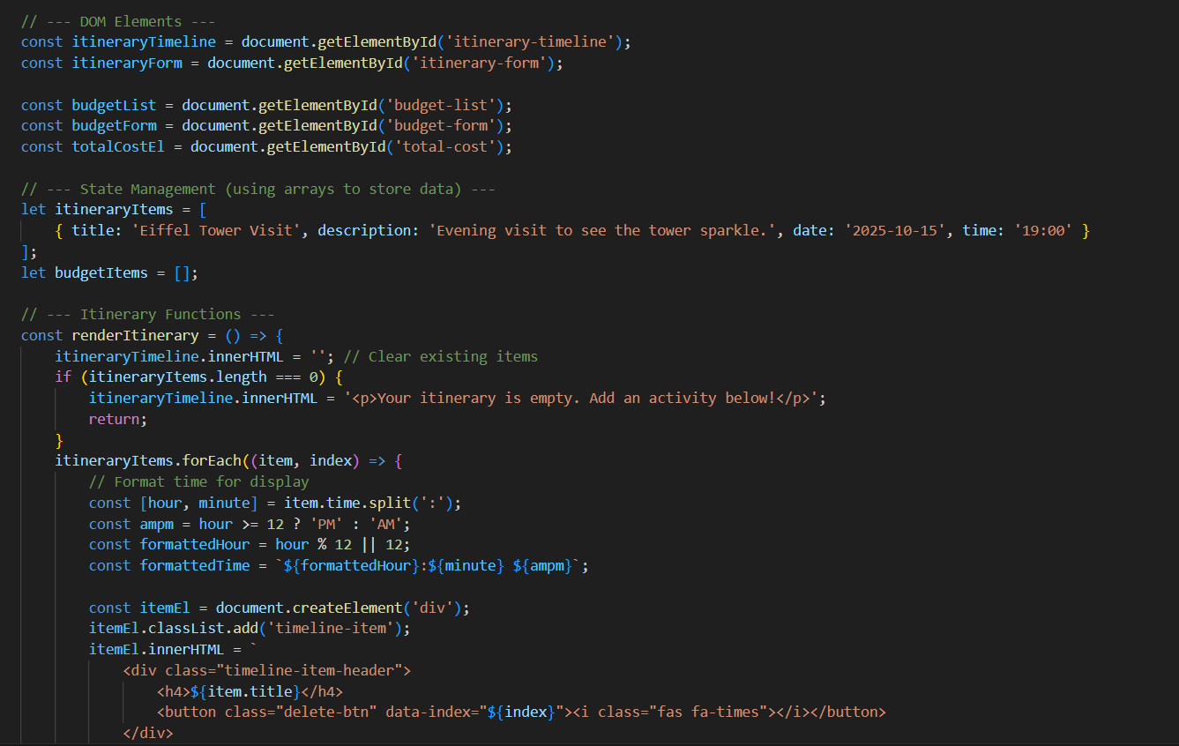

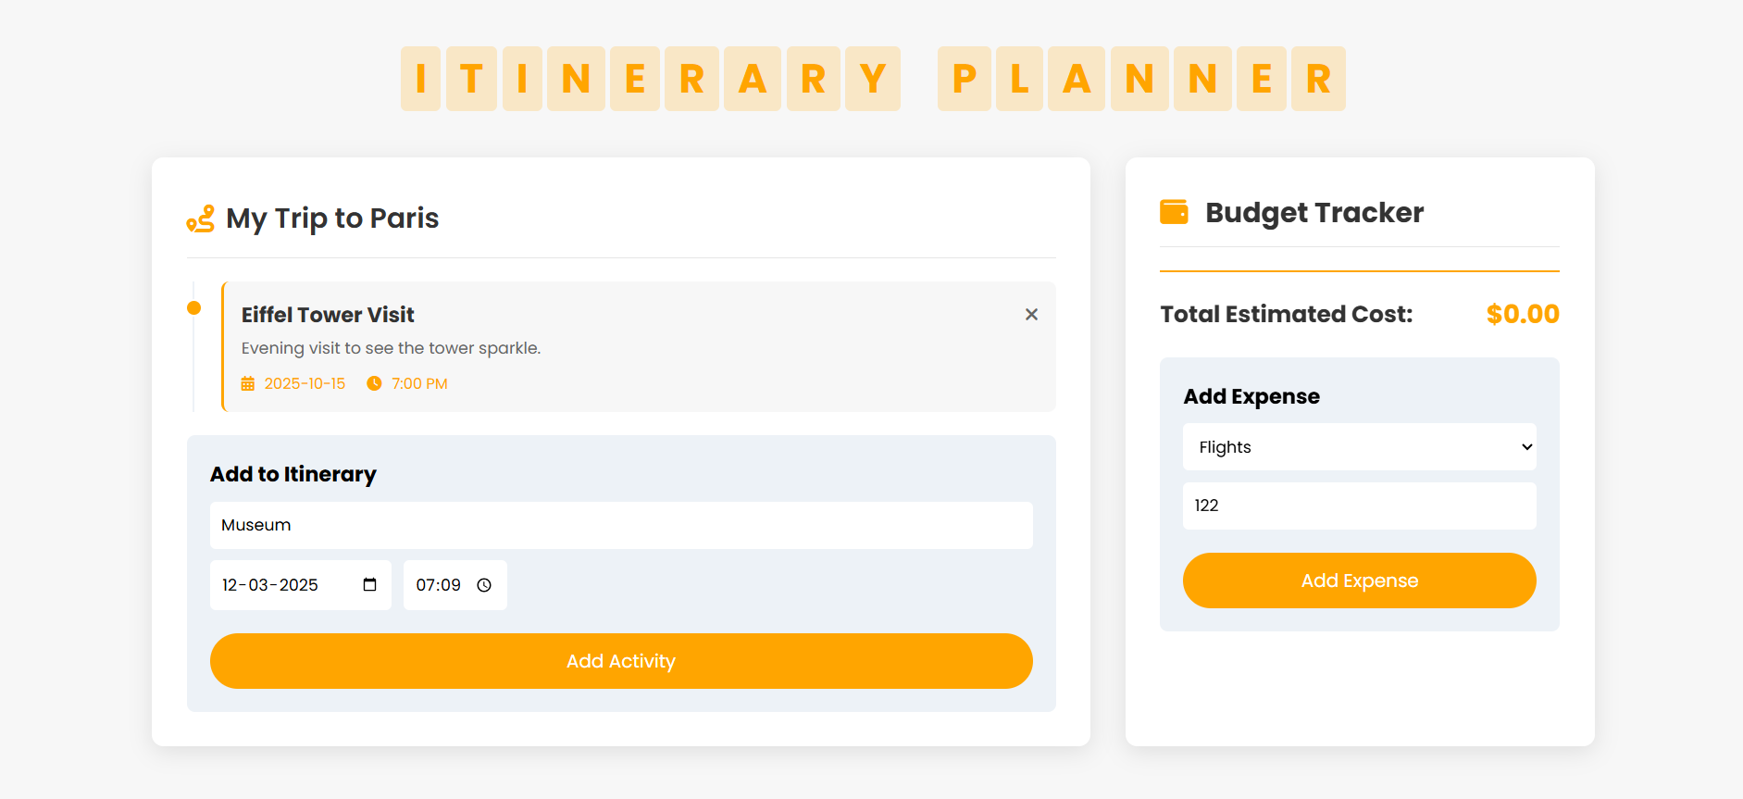

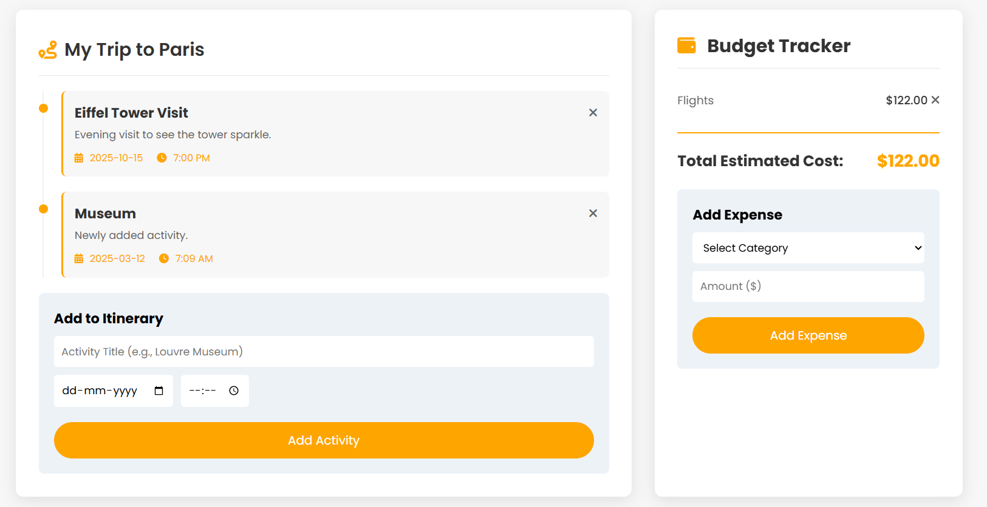

**>> Custom Animated Image Carousel:**

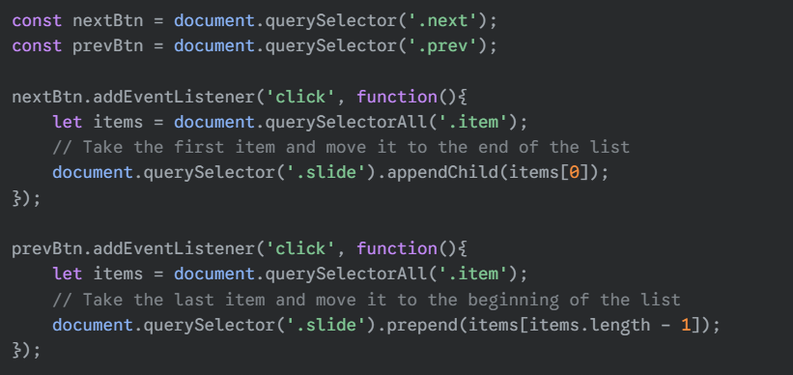

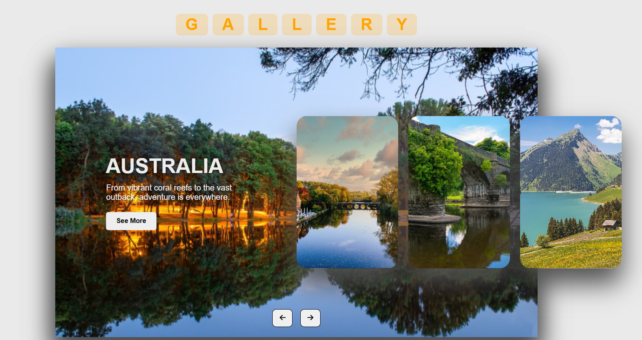

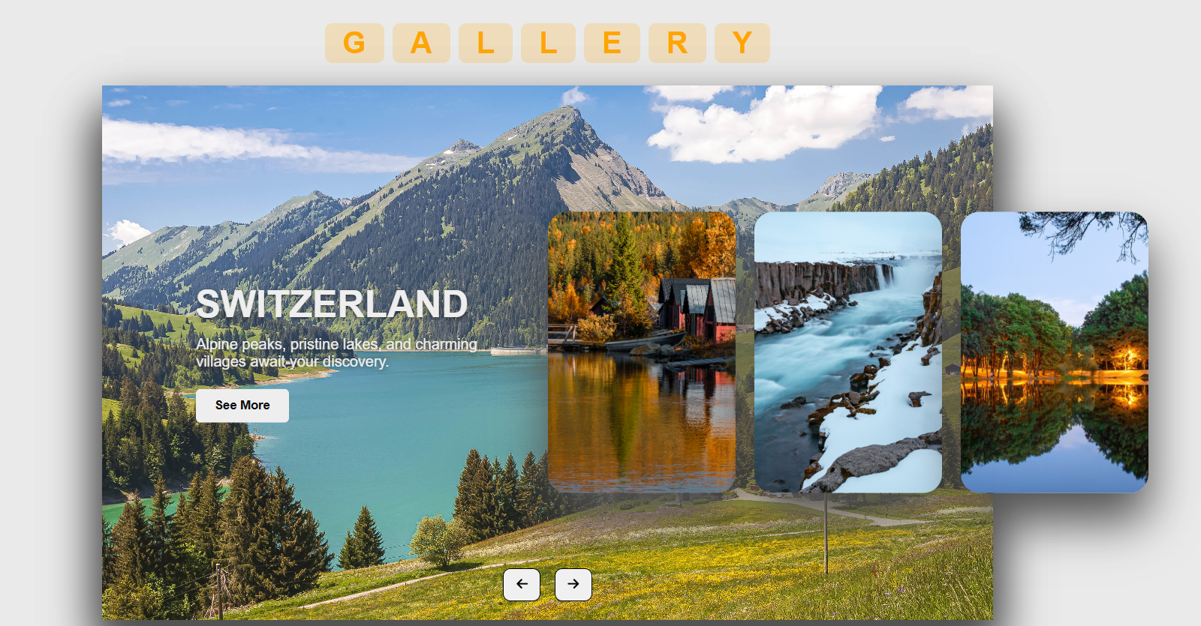

**>>Pop-Up Service Modals:**

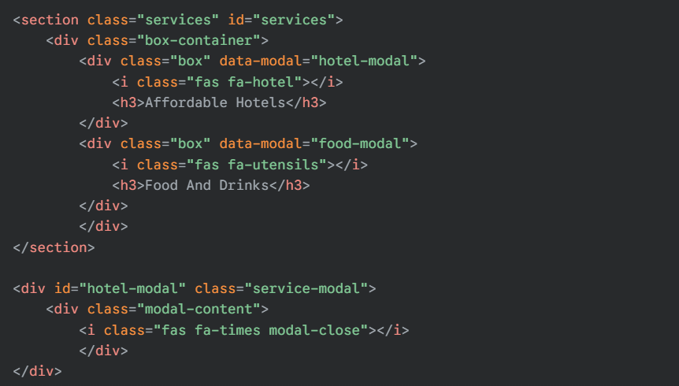

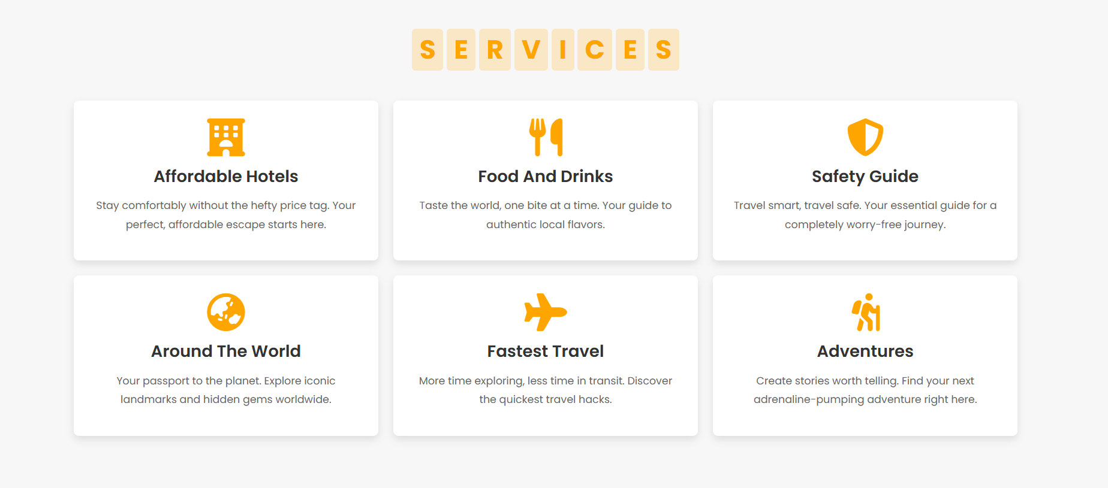

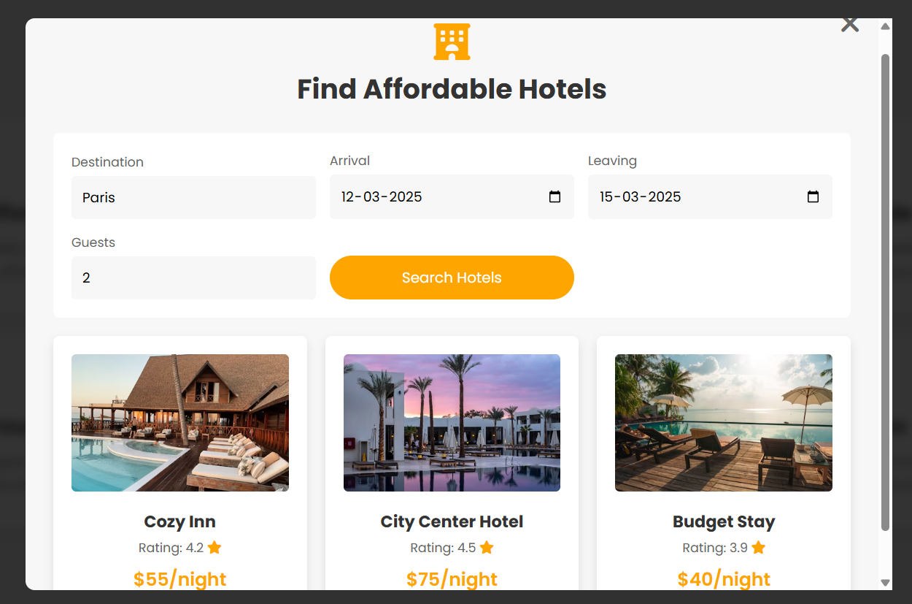

**>> Responsive Testimonial Slider:**

